Project Report

Introduction:
The goal of this project is to develop a predictive model that can accurately identify customers who are likely to default on their loans. This project is crucial in the banking industry, as it can help banks minimize their losses and make informed decisions about lending. By building a reliable predictive model, banks can reduce their risk exposure and improve their overall profitability. In this project, we aim to achieve this goal by using a dataset containing historical data.

This data set contains historical data of the customers who have taken loans from the German bank. The bank has historical information on relevant features for each customer such as employment duration, existing loans count, saving balance, percentage of income, age, and default status, and these relevant features, except default, can act as the predictor variables and response variable in building a model. By building a model with these many features one can also find the feature that is best suited in predicting the default status, by finding the one feature which has the strongest relationship with response variable - default.

This dataset with diverse features do however have significant number of missing values in two categorical features of the dataset, which could significantly impact the model building. To deal with the missing values 2 imputer methods, Simpleimputer and KNNimputer, were employed. Simple Imputer is used to fill the missing values of the feature with the mode of feature, whereas KNN imputer is used to predict the missing values of the feature using KNN algorithm, another supervised machine learning model, with k=2. While in one method all the missing valued rows are dropped. As for the choice of algorithm used for training the model Logistic Regression is used due to its popular choice as a machine learning technique for binary classification problem, such is the case in this problem as well where we have to predict a binary feature, target. So a total of 3 models are trained using Logistic Regression to find the best one, by comparing the accuracies of the models, for the problem of predicting the default status.
Methods and Materials:
We use Python for data exploration, cleaning and modelling. We start by loading the dataset and performing exploratory data analysis (EDA) by using count plot of seaborn library to display histograms of each and every predictor variable against default(target feature). It looks as follows, 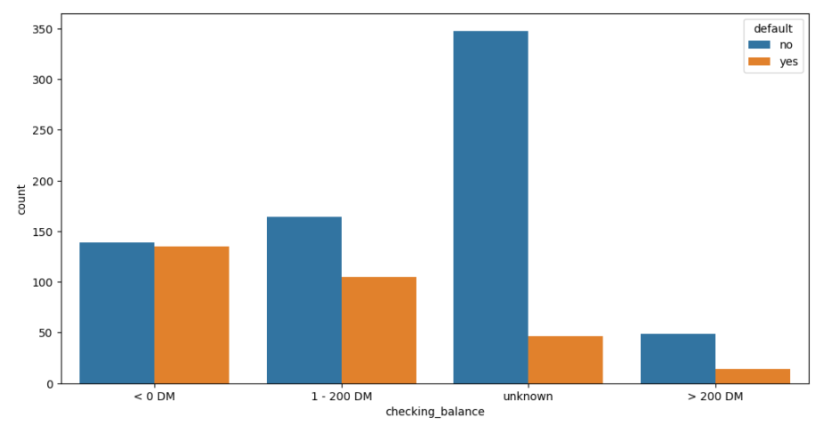
Fig 1: checking_balance VS default count

We can see that checking_balance is a categorical feature and has 4 unique values with ‘unknown’ being the most commonly occurring one in terms of customer not defaulting and overall while most defaulting is occurring at checking balance < 0 DM. In this project it was assumed that unknown refer to missing values and treated as such. This is the type of information extracted from the count plot of this project and similar 15 more histograms like this are drawn, for each predictor variable with the exception of amount, because it is a numeric type data and its count plot looks messy and un-viewable. Rest of the histogram plots can be found in list of Figures at the end of the report, if you’re interested in viewing them.
The info() method of data frame is also used for additional information like feature’s data type so that necessary pre-processing can be done before model building. The output of df.info() looks something as follows,
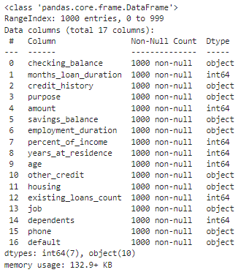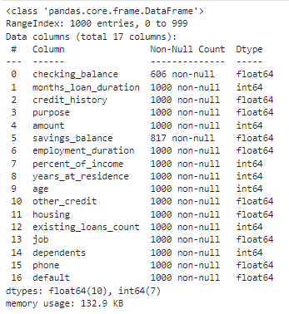
Fig 16: Before Pre-processing Fig 17: After Pre-processing
As you can see in Fig 16 there are 10 features that have object type data before Pre-processing, which have to be changed to a numeric type for the model building. This conversion to numeric is done by label encoding and casting the data into a float. You should also convert the unknown values in checking_balance and savings_balance into Nan using np.nan, so that they can be viewed as missing values and be dealt with easier. You can refer to the histogram figure while label encoding to know unique values of the object feature. After Pre-processing the info table should look something like Fig 17.
The decrease in Non-Null count of checking_balance and saving_balance is due to the unknown values being treated as Null/missing values. Now onto dealing with the missing values, this is done in 3 ways, 2 imputer methods and 1 brute force method –
- Dropping the missing valued rows entirely and risk compromising the data quality and the model performance.
- The missing values are filled with mode of that feature.
- The missing values are predicted using another model.
After Finishing the Pre-processing it is time to choose the algorithm to use for training the model. Keeping in mind the fact that we are trying to predict the binary valued feature, Logistic Regression is used for model building in this project.
To implement Logistic Regression two python liraries are used –
- Sklearn’s LogisticRegression
- Statmodels’s Logit

We use train the model using Logistic Regression of sklearn so that it can be tested for its accuracy using accuracy_score from sklearn_metrics. After finding its accuracy we decide if this model’s accuracy is high enough for us to study the statistical significance of each predictor variable and thier relationship with response variable using the Logit object’s summary method.

The above process is done three times with each of the ways we dealt with the missing values. The first model is built on dataset that dropped all the missing valued rows. The second model is built on dataset that filled the missing values using Simpleimputer, This model is trained to compare the accuracies of this model and the third model. The third model is built on dataset that filled the missing values using KNNimputer. I viewed this imputer as the most accurate in predicting the missing values because it uses model based prediction to fill the missing values. And as mentioned above one of the reasons for building the 3rd model is to compare its accuracy with 2nd‘s to experience the normal imputer concept, which states that mode can be used to fill the missing values of categorical without affecting the accuracy significantly.

Results:
We found that the third model which was trained on dataset which filled the missing values using model based imputer, KNNimputer, performed the best out of the three models with an accuracy of 70%, this model also identified important features that contribute to predicting if a customer defaults. These features include month_loan_duration, credit_history, amount, savings_balance, employment_duration, percent_of_income, age, existing_loan_count, phone. One of the findings is that people who has a longer emplyment duration and higher savings balance are less likely to default.
Another Intresting finding that can be found is that more perfect a credit history, more likely it is that a person would try to default. This finding is intresting because one would thing it’s the opposite, more perfect the credit history less likely it is that a customer will try to default a loan.

Discussion:
The findings of longer employment and higher savings balance is derived from the following summary table of third model,
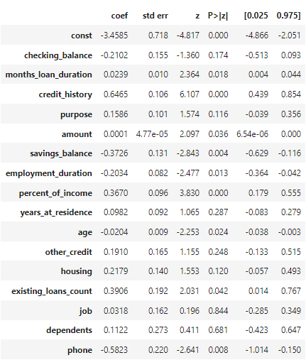
Fig 18: Summary table of model 3
You can see that all the important features mentioned in Result are deemed to be important due to their statistical significance(low p-value). Now if you look at savings_balance and employment_duration they both have negative coefficients signifying a negative relation with response variable, defaut, hence the finding that higher savings_balance and employment duration leading to less likely loan defaulting. Similar findings can also be interpreted such as older people are less likely to default a loan.

As for the finding with the credit_history it can be found in a similar way above findings were found, credit history is statistically significant and its coefficient value is positive signifying a positive relationship. Hence more perfect the credit history more likely it is they will default. If you look at the Fig 3 this fact is cemented, There are more people with perfect and very good credit history that default than those who do not default. Its almost as if people are trying to build credit so that they can default.

In Future Works, We can consider ‘unknown’ values of checking_balance and savings_balance as unqiue case instead of missing values and study its affects on the trained model and compare how it is different from the current model. We can also try to build models using other techniques such as Random Forest and Decision Trees to find out the most effective approach for predicting loan defaults.

Conclusions:
In conclusion, we have developed a predictive model that can help identify customers who are likely to default on their loans. Using historical data, our model is able to predict the chance of a customer defaulting on their loan with an accuracy of 70%. While this accuracy is not perfect, it can still be useful in identifying high-risk customers and taking appropriate action. Additionally, our findings suggest that certain features are particularly important in predicting loan defaults.

List of Figures

Fig 1: checking_balance VS default count

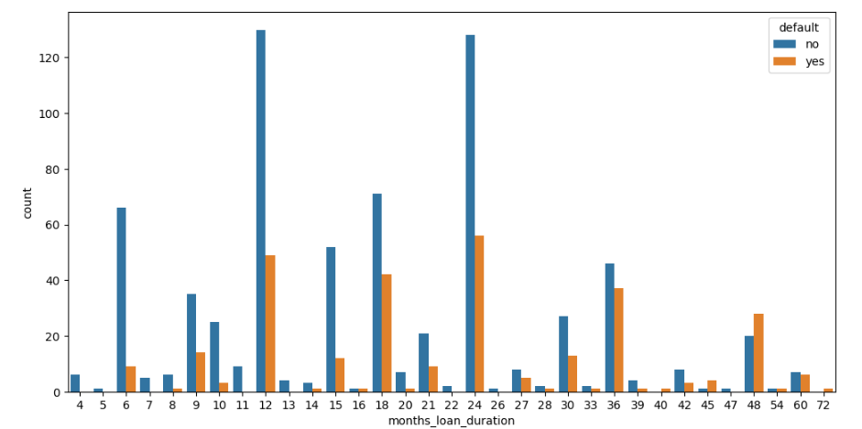
Fig 2: months_loan_duration VS default count
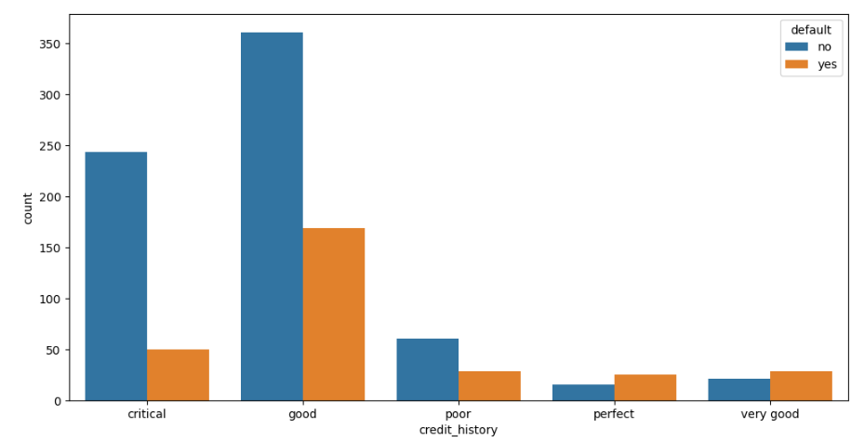
Fig 3: credit_history VS default count

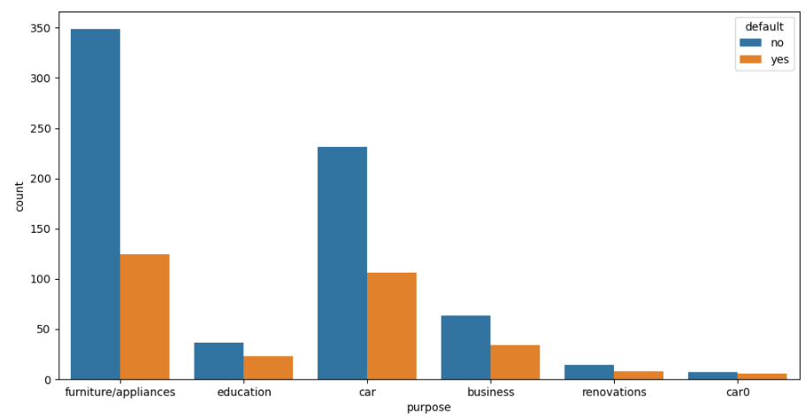
Fig 4: purpose VS default count
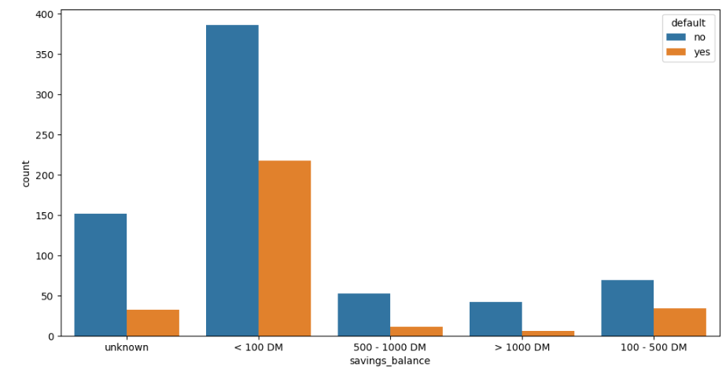
Fig 5: savings_balance VS default count

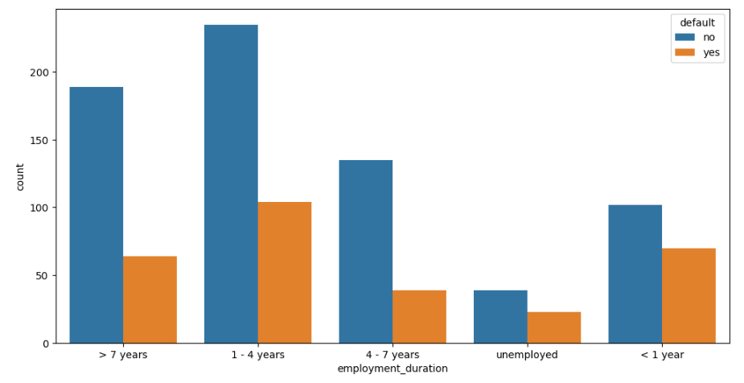
Fig 6: employment_duration VS default count

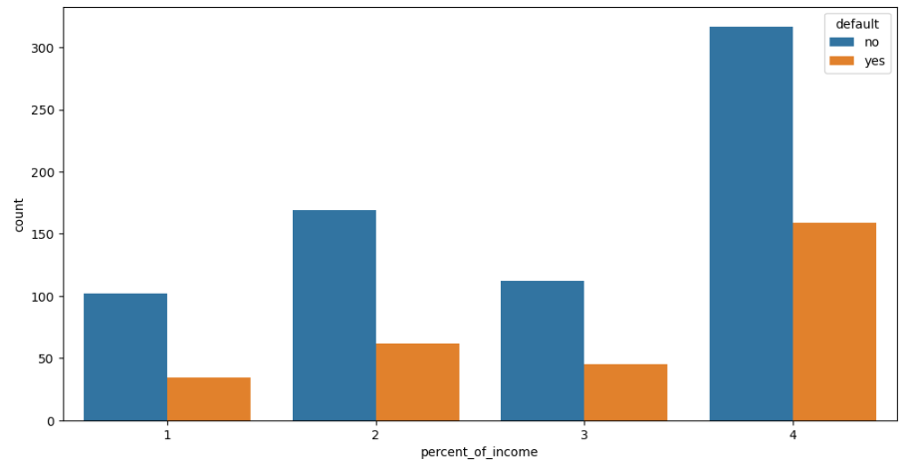
Fig 7: percent_of_income VS default count

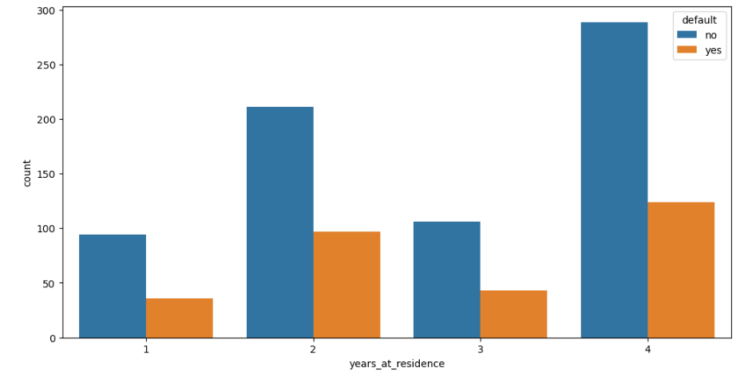
Fig 8: years_at_residence VS default count
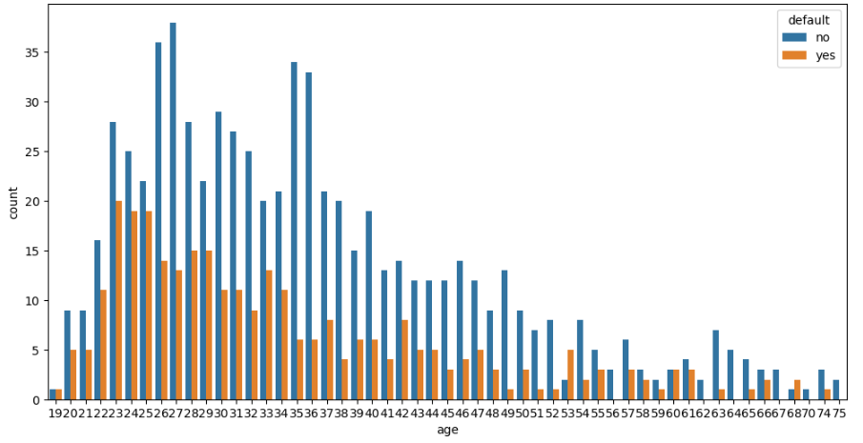
Fig 9: age VS default count
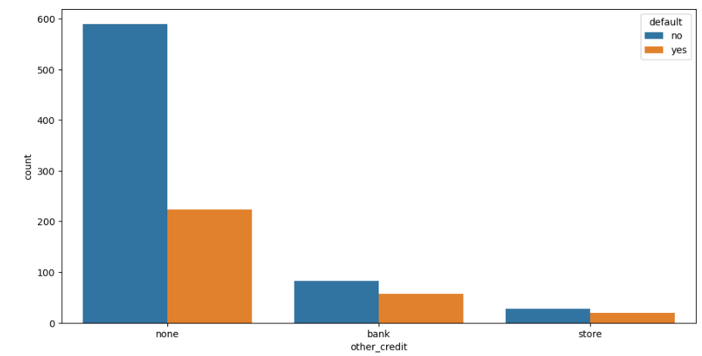
Fig 10: other_credit VS default count

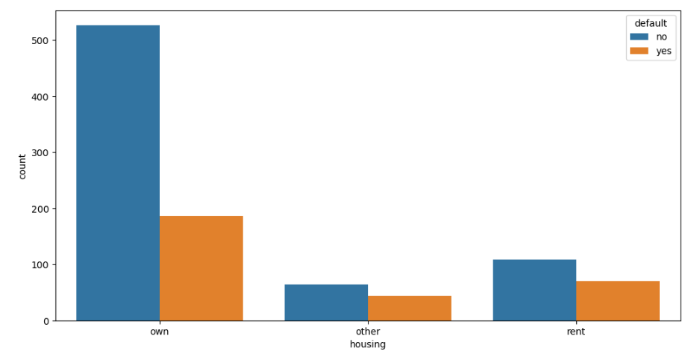
Fig 11: housing VS default count
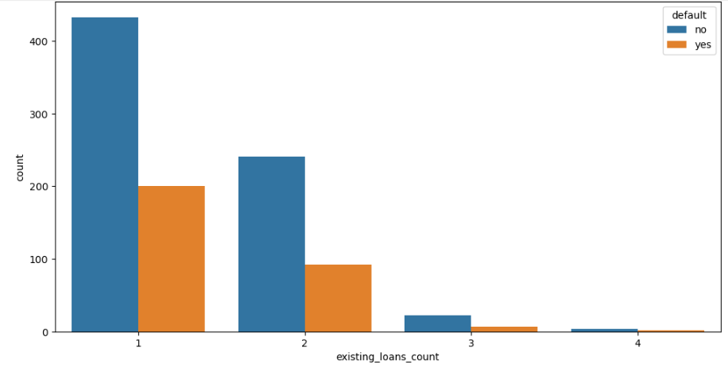
Fig 12: savings_balance VS default count
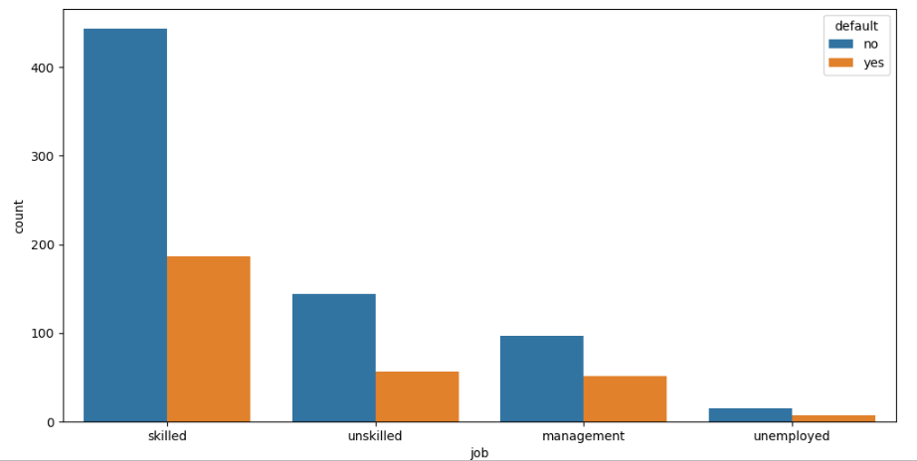
Fig 13: savings_balance VS default count
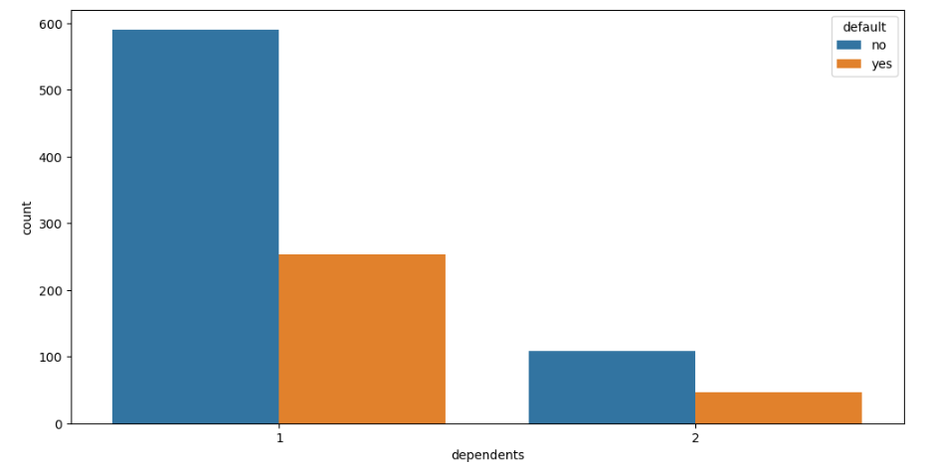
Fig 14: savings_balance VS default count
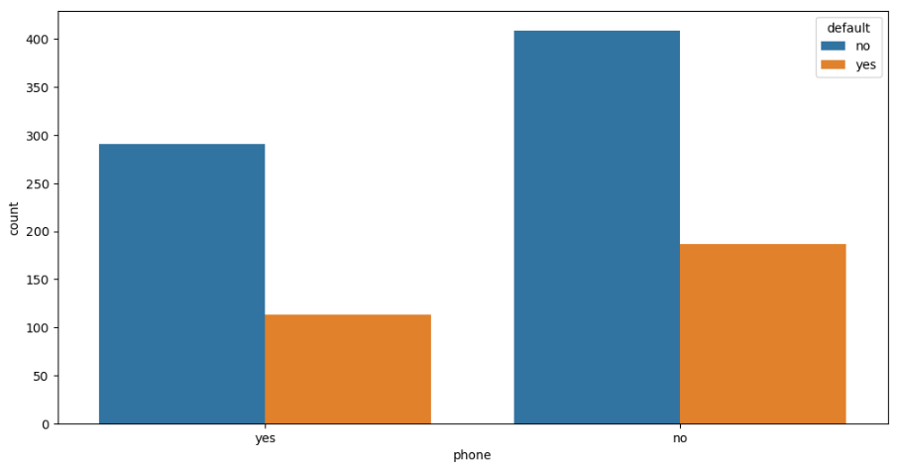
Fig 15: savings_balance VS default count

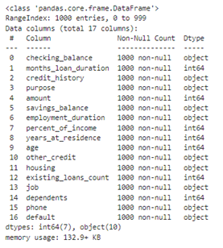
Fig 16: Before Pre-processing

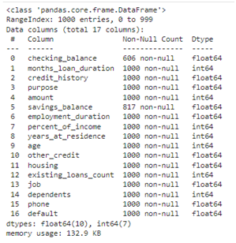
Fig 17: After Pre-processing
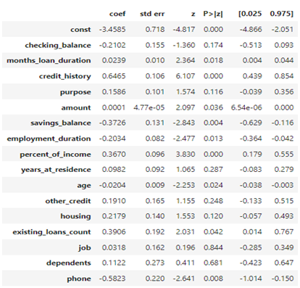
Fig 18: Summary Table for model 3

